**The Path to Carbon Neutrality**

**Guide on How to Turn Business Schools Carbon Neutral**

Graduate Business Conference 2012

William E. Simon Graduate School of Business Administration

University of Rochester NY



Authors: Alex Song, Eric Seidner, Dr. Robert Seiler  
Sponsorship: CEIBS, GBF and DunAn Group  
Date: March 30, 2012

Contents

Introduction 3

Climate Change 3

Steps to Carbon Neutrality 5

Identification of Greenhouse Gas Emissions 7

Calculate a Carbon Footprint 7

Standards for Calculating a Carbon Footprint 8

Reduction of Greenhouse Gas Emissions 9

Neutralization of Greenhouse Gas Emissions 11

Options for the Neutralization of Greenhouse Gases 11

Standard for Carbon Neutrality 12

Cost Estimate 12

Acknowledgments 12

Appendix 13

A. CEIBS Carbon Footprint Tool 13

B. The Greenhouse Gas Protocol 13

C. PAS2060 13

D. Emission Factors defra 13

E. IPCC Global Warming Potentials 14

F. Contacts 15

# Introduction

A team of students of the MBA 2010 class at the China Europe International Business School (CEIBS) in Shanghai made in the course for Responsible Leadership a business plan for turning their campus carbon neutral. The team called themselves Decarbonators and was comprised of Robert Seiler, Alex Song, Yusuke Ozeki, Michelle Da and Don Ni. The CEIBS management liked the thought of being the first business school in Asia that is carbon neutral and supported the Decarbonators in the realization of their plan from 2010 onwards. In the course of realizing the business plan, another member Eric Seidner joined the team. In May 2011, CEIBS announced to be fully carbon neutral. In the following, the Decarbonators were given the Responsible Leadership Award and Grant by the Graduate Business Forum at the GBC 2011 in Barcelona. Since then, the Decarbonators were aiming to convince other business schools around the globe to join the initiative and become carbon neutral. The goal is to have an even larger impact on the fight against climate change and to make MBA students, the future business leaders, aware of the environmental problems of our planet. This document shall be used as a user manual for turning business school campuses around the globe carbon neutral. The Decarbonators from CEIBS will support students, who decide to turn their business school carbon neutral.

# Climate Change

Climate change is no threat to life on Earth in general, but to the existence of our species homo sapiens. The cause of global warming lies in the anthropogenic emission of greenhouse gases that started during the industrial revolution, when the developed countries began to burn large amounts of fossil fuels. These gases cause our atmosphere to slowly heat up, which shifts the climatic zones on our planet. European and North American societies are the originators of climate change. But the dislocation of the climatic zones has particularly negative effects on the less developed, poorer societies on Earth. People in Pakistan suffer from severe floods, inhabitants of central China die in landslides and more and more Africans starve due to long lasting droughts. The regions that are least responsible for climate change cannot afford to prepare themselves for the dangers yet to come. The United Nations and several scientists expect over 250 million climate refugees on our planet until 2050[1]. This will lead to large migrations, refugee camps, shortage of food and water, diseases and maybe even war.

The United Nations try to slow down global warming with a system of regulations and market mechanisms embedded in the so called carbon market. The idea is that the emission of one metric ton of greenhouse gases such as CO2 to the atmosphere must have a certain cost. Whoever emits these gases shall reduce their emissions or pay for the reduction of the same amount of greenhouse gas emissions somewhere else. The latter process is called compensation or offsetting. The international agreement summarizing the mechanisms and rules for emission reduction is called *Kyoto Protocol*. Up to now, only 37 industrial countries have agreed to reduce and compensate a part of their greenhouse gas emissions. Within these so called Annex B[2] countries, only a small proportion of emitters – mainly from the heavy industry – are legally obliged to compensate their emissions. Other emitters can of course voluntarily compensate. Many service providers such as banks or insurance companies do so in order to improve their reputation by building a green image.

Controversially, many companies that, mandatorily or voluntarily, compensate their emissions do that in third world countries, where this can be done to much lower costs than at home. The *Kyoto Protocol* approves this compensation abroad for two reasons: transfer of technology from industrialized to developing countries and foreign investments in the developing world. But many critics say, this procedure is unfair. Countries that are not responsible for climate change have to carry a large part of the burden of emission reduction. The first world, that is responsible for global warming, shifts the responsibility on to the third world.

Annex B countries reduce their emissions with a market based mechanism called cap-and-trade emissions trading scheme. The government distributes a certain amount of emission allowances that can be traded between companies. Only with the appropriate amount of allowances companies are allowed to operate their greenhouse gas emitting plants or processes. In addition to these emission allowances, companies can use so called emission reduction certificates. These certificates are produced in emission reducing projects – mainly in developing countries as discussed before. The world’s largest emissions trading scheme is the European ETS.

China, where CEIBS is located, has not agreed to any emission reduction target in the *Kyoto Protocol* and is therefore a non-Annex B country. But China is making a lot of progress in reducing emissions voluntarily. China is also the largest producer of emission reduction certificates (72%, see Exhibit 1). It makes a considerable profit in selling these certificates to the developed countries with binding emission reduction targets. Three voluntary environmental stock exchanges were established in Beijing, Tianjin and Shanghai in 2008. These are pilot projects for testing the use of domestic emissions trading. They serve as a tool to support China’s climate change mitigation strategy, but do not involve the central government[3].

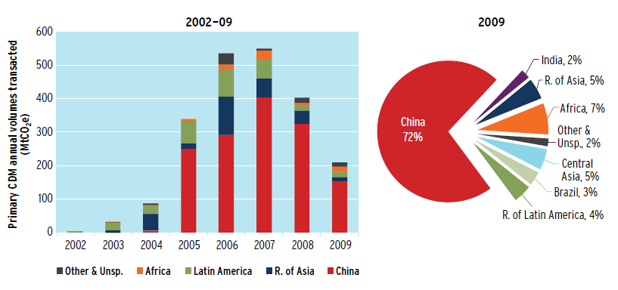

**Exhibit 1: China as largest supplier of project based emission reduction credits (Source: World Bank)**

Business schools around the globe have no obligation to measure, reduce or compensate their emissions. But they can do so voluntarily to contribute their part to the fight against climate change, to show their commitment to sustainability and to educate and guide the community that lives, works, studies and teaches on their campuses. Business schools build the future business leaders of our society. A large part of our world’s fate lies in their hands.

# Steps to Carbon Neutrality

The Kyoto Protocol states six different types of greenhouse gases that contribute to the anthropogenic greenhouse effect. Carbon Dioxide (CO2) is the most abundant and contributes to about two third of the man-made greenhouse effect[4]. It is emitted when fossil fuels such as oil, gas or coal are burned. Methane (CH4) and Nitrous Oxide (N2O) emerge from agriculture, cattle breeding and landfills. Together they contribute to around one quarter of the man-made greenhouse effect. The so called F-gases Fluorocarbon and Sulfur-Hexafluoride are synthetic greenhouse gases that are used as cooling agents or isolation in electric high-power switches. They contribute to about ten percent of the man-made greenhouse effect (see Exhibit 2).



**Exhibit 2: The six types of greenhouse gases according to the *Kyoto Protocol***

The six different types of greenhouse gases have considerably different global warming potentials (GWP), i.e. a certain amount of a greenhouse gas can heat the atmosphere much more than the same amount of another greenhouse gas. In order to make their contribution to the man-made greenhouse effect comparable, all greenhouse gases are normalized to the effect of the weakest of all greenhouse gases – CO2. E.g. one metric ton of Nitrous Oxide has the same heating effect on the atmosphere as 298 metric tons of Carbon Dioxide. The international unit to measure and compare all greenhouse gases is tons of CO2-equivalents (tCO2e).

Carbon neutrality is a widely used expression. An institution is carbon neutral if it does not emit any greenhouse gases or it compensates for the entirety of its emissions. A carbon neutral institution does therefore not add to the anthropogenic greenhouse effect and has no additional heating effect on the atmosphere. Compensation of emissions means the reduction of emissions somewhere else on one’s behalf. Only with the process of compensation, institutions like business schools who use fossil fuels can become carbon neutral.

A classical way to achieve carbon neutrality is the three step process shown in Exhibit 3. An institution first needs to identify its greenhouse gas emissions. Based on this analysis it can identify opportunities to reduce some or all emissions with certain measures. If the institution still has some residual emissions, it can compensate (also called *offset*) them by reducing emissions somewhere else and become carbon neutral. The mechanism of offsetting makes sense, since the greenhouse effect is independent of the location where gases are being emitted or reduced. But some locations offer much cheaper and easier ways to reduce greenhouse gases than others. The following chapters describe, how a business school can implement the three steps to carbon neutrality on the model of the China Europe International Business School in Shanghai.



**Exhibit 3: Three steps to carbon neutrality**

# Identification of Greenhouse Gas Emissions

## Calculate a Carbon Footprint

A carbon footprint is a way to measure and compare greenhouse gas emissions of an institution, a product or a process. It adds up all emissions, no matter what the source is. Burning a liter of petrol causes a certain amount of CO2 emissions, dumping a ton of green waste in a landfill causes a certain amount of methane emissions and having a leak on the aircon and losing the cooling agent causes the emission of a certain amount of F-gases. A carbon footprint converts the raw data such as liter petrol, ton of green waste or kilograms of F-gas into greenhouse gas emissions such as tons of CO2 or tons of CH4. Using a number called Global Warming Potential (GWP), the impact of the different greenhouse gases on global warming is normalized to the impact of CO2 under the unit of ton of CO2-equivalent (tCO2e). To demonstrate the simplicity of this calculation, a few examples are given below.

* A car that drives 5000 kilometers uses for example around 500 liter of petrol for that distance. This number is called *raw data*. Burning 1 liter of petrol causes 0.00217 tons of CO2 emissions. This number is called *emission factor*. The *global warming potential* of CO2 is 1 by definition. Therefore, the car emits 500 liter * 0.00217 tCO2/liter * 1 = 1.085 tCO2e for the distance of 5000 kilometers. The formula is always of the same structure:  
    
  **Raw Data * Emission Factor * GWP = Emissions in tCO2e (1)**
* A family with two children living in a house uses around 5000 kWh of electricity per year (raw data). The electricity production in their country uses coal and gas fired power plants, which results in emissions of around 0.0008 tCO2/kWh (emission factor). Again, the GWP of CO2 is 1. Therefore, the family emits around 5000 kWh * 0.0008 tCO2/kWh * 1 = 4.0 tCO2e per year due to electricity consumption.
* An aircon system uses the F-gas R134a (also called F134a) as cooling agent. Because of a leak, 1 kilogram of R134a is released to the atmosphere by accident. The GWP of R134a is 1430, which means that releasing 1 ton of R134a to the atmosphere has the same warming effect as 1430 tons of CO2. Therefore, releasing 1 kilogram of R134a is equal to 0.001 tR134a * 1430 = 1.43 tCO2e.

A carbon footprint would add the numbers above and come to the conclusion that driving 5000 km, using 5000 kWh and releasing 1 kg of R134a to the atmosphere result in the total carbon emissions of 6.515 tCO2e. The largest part comes from the consumption of electricity. Therefore, the easiest way to reduce carbon emissions in this example would be to reduce electricity consumption.

A tool to calculate a carbon footprint developed by CEIBS is given in Appendix A. To calculate a carbon footprint for a business school, one needs three types of data:

* Raw data of activities that produce carbon emissions. They can be gathered at the engineering office, financial office etc. A list of activities that produce carbon emissions is given in the CEIBS Carbon Footprint tool in Appendix A. This list is probably not complete, since there can be emissions in a business school that are unique to a school.
* Emission factors to convert raw data into carbon emissions. These data can partly be found in the list given in Appendix D. Certain emission factors can be used unaltered around the globe, but others are very specific to the region where the carbon footprint is to be calculated. The emission factor of electricity production is the most prominent of these regional emission factors. They can be found online in statistical environmental data.
* Global Warming Potential GWP to convert greenhouse gas emission to CO2-equivalents. The Intergovernmental Panel for Climate Change IPCC regularly publishes GWP’s in their Assessment Reports. A list of GWP’s is given in Appendix E[5].

## Standards for Calculating a Carbon Footprint

In the following, we discuss the relevant regulatory aspects on performing Carbon Footprints. There are several important global standards used and only these standards guarantee that the results of carbon footprints calculated around the globe are in a certain way comparable.

* *ISO 14064-1: Specification with guidance at the organization level for quantification and reporting of greenhouse gas emissions and removals*  
  This standard is specifying quality measures that can be implemented in companies who perform a Carbon Footprint. It is globally used but rather defined for large companies that also follow other ISO standards. This standard suggests, that every Carbon Footprint should be based on the rules given in the Greenhouse Gas Protocol. Business schools do not have to follow the ISO 14064-1 standard for the Carbon Footprint because it only defines very broad and general rules.
* *The Greenhouse Gas Protocol*The Greenhouse Gas Protocol is a step-by-step guide for companies to quantify and report their greenhouse gas emissions. This globally used standard has been designed to make Carbon Footprints comparable around the world. It is publically available[6] and given in Appendix B. Carbon Footprints for business schools should be evaluated according to this standard. The most important aspect of the Greenhouse Gas Protocol is the description how to define system boundaries. It divides all greenhouse gas emissions of an entity into three scopes (see also Exhibit 4):
  + Scope 1: Emissions from sources that are owned and controlled by the entity such as CO2 emissions of the company-owned fossil fuelled heating system.
  + Scope 2: Emissions outside of the entity caused by the import and use of external energy such as purchased electricity or steam.
  + Scope 3: All other emissions outside of the entity caused by the import and the use of goods. This scope also includes life cycle emissions of goods due to their production and disposal.

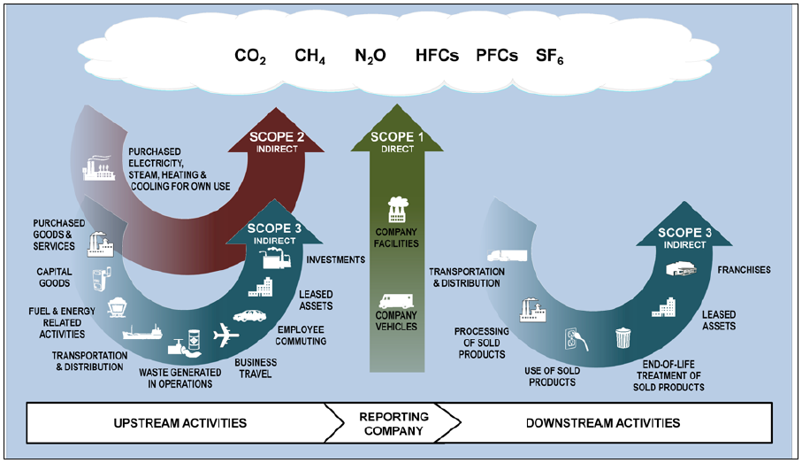

**Exhibit 4: Overview of Scopes and Emissions across the Value Chain (Source: GHG Protocol)**

Carbon Footprints prepared under the rules of the Greenhouse Gas Protocol mandatorily have to report all Scope 1 and Scope 2 emissions. Entities can voluntarily (if relevant) also report parts of (or all, if possible) emissions in Scope 3. For companies with production facilities, Scope 1 and 2 usually cover the largest part of the emissions. But for service companies, Scope 3 usually represents a major part of the overall greenhouse gas emissions and can therefore not be neglected. Since business schools are service companies, certain relevant emissions of Scope 3 should be included in a carbon footprint. The decision, which material streams on a campus usually generate relevant amounts of greenhouse gas emissions (and should therefore be included in a Carbon Footprint) can be done with the help of third parties such as SGS or DNV, who have a large experience in this field.

# Reduction of Greenhouse Gas Emissions

Once a carbon footprint for a business school is calculated, the results show the sources and activities on campus that cause the largest carbon emissions. Exactly these sources and activities should be tackled when reducing emissions, since there often are “low hanging fruits”, where emissions can be easily reduced without large investments. The second step of the carbon neutrality process (Exhibit 3) is the most important but also the most difficult part on the way to carbon neutrality. It is important because it is using the outcome of the previously calculated carbon footprint in order to reduce emissions that are directly or indirectly caused by the business school. This is the step, where emissions can be reduced that the business school is directly responsible for. Reduction of greenhouse gas emissions is at the same time very difficult, since the measures to be taken cannot be standardized. Every institution has different sources and activities for emissions. One institution might have a very modern and energy efficient heating system whereas another institution might have an old and inefficient system. The first institution cannot reduce emissions by replacing the heating system, but the second one can. Therefore, the implementation of emission reduction projects can only be planned after having calculated a carbon footprint and analyzed the opportunities specific to the institution under investigation. Reduction measures cannot be standardized and we therefore only give an incomplete list of measures typical for this third step.

* Increasing energy efficiency
* Biomass power and heat
* Photovoltaic solar panels
* District heating
* Energy contracting
* Biofuels
* Optimized building services engineering
* …

Typical carbon emission reduction measures can be classified in five segments given in Exhibit 5. A business school can decide, which one of the measures given above, are technically and economically feasible. This decision can be made with the help of third parties such as SGS, DNV or any engineering firm that can also perform an energy check on campus. Third parties are often willing to sponsor an energy check in the hope to sell emission reduction projects, to become sponsor or partner of a business school or simply to work together with the students on campus who are running the carbon neutrality project in order to hire them after graduation.

In conclusion, the second step of the carbon neutralization process (Exhibit 3) is the most important. Only by reducing at least a part of the emissions caused by a business school, the institution can show its commitment to climate protection. The actions of schools that are only performing steps 1 and 3 (identification and neutralization) can be considered as green washing. This should be avoided at all cost.



**Exhibit 5: Emission Reduction Measures**

# Neutralization of Greenhouse Gas Emissions

## Options for the Neutralization of Greenhouse Gases

Usually, an institution such as a business school is not able to fully reduce their carbon emissions down to zero. Some emissions can technically not be avoided or their reduction would be too costly. Business schools have the option to compensate or offset their residual emissions and become fully carbon neutral. They have several options to do that.

* Planting trees that absorb CO2 from the atmosphere. A permanent carbon emission reduction by planting trees is only guaranteed if trees are cultivated and replanted after their life span. The exact amount of CO2 absorption depends on the type of the tree and on the environment where it grows. Organizations such as *Roots & Shoots* offer their customers to plant forests in areas that have been deforested in former times. They have scientific data on the amount of carbon absorption by these trees.
* Purchasing carbon credits. A carbon credit is a proof for carbon emission reduction by a project. Project developers and investors implement clean tech projects that reduce carbon emissions. Third parties such as SGS and DNV audit these projects and measure their emission reducing effect. According to the amount of annual reduction, these third parties issue carbon credits for the project owners. Business schools can directly support these projects by purchasing carbon credits or investing in projects and receiving credits as dividends. These carbon credits can officially be used to offset or neutralize residual carbon emissions on campus. There are several types of carbon credits on the market that suit the demand of business schools:
  + VER, Verified Emission Reduction
  + VCU, Voluntary Carbon Unit
  + GS VER, Gold Standard Verified Emission Reduction

Carbon Brokers such as *Evolution Markets* can help business schools choosing the right projects and credits that suit the school. Projects (and therefore their carbon credits) differ by technology, geography and of course by price.

## Standard for Carbon Neutrality

Carbon neutrality is a widely used term. There have been large differences around the globe about the definition of carbon neutrality and several cases of fraud. In 2011, the British Standard Institution has therefore published a global standard on how to understand and implement carbon neutrality for institutions – the PAS2060 standard. If business schools want to prove that their “carbon neutrality project” really means, that they have no longer any negative impact on climate change, they should perform their project according to PAS2060. Third parties such as SGS or DNV can audit a carbon neutrality project and approve that it is implemented in accordance to PAS2060. A short summary of what this standards stands for is given in Appendix C.

# Cost Estimate

In the following, we would like to give a very brief cost estimation for each step of the carbon neutrality process.

1. Identification of greenhouse gas emissions is free. An audit of the results by a third party such as SGS or DNV will cost around USD 10,000.
2. Reduction of greenhouse gas emissions is the most costly part of carbon neutralization and can only be valued when specific measures are defined.
3. Neutralization of greenhouse gas emissions can be done by purchasing carbon credits. A standard VER has costs of around 2-10 USD/tCO2e, depending on the quality and the type of credit. An audit of carbon neutrality according to the PAS2060 standard performed by a third party such as SGS or DNV costs around USD 20,000.

# Acknowledgments

The CEIBS Carbon Neutrality project could only be implemented with the help and support of the management of the China Europe International Business School. Special thanks go to Prof. Lydia Price and Laurie Underwood. The CEIBS Decarbonator team could only attend the GBC 2012 thanks to the sponsorship of the DunAn Group and the Graduate Business Forum. Special thanks go to Ge Yafei from DunAn and Jim Deveau and Wieteke Dupain from the GBF.

# Appendix

## CEIBS Carbon Footprint Tool



## The Greenhouse Gas Protocol



## PAS2060



## Emission Factors defra



## IPCC Global Warming Potentials

<http://www.ipcc.ch/publications_and_data/ar4/wg1/en/ch2s2-10.html>

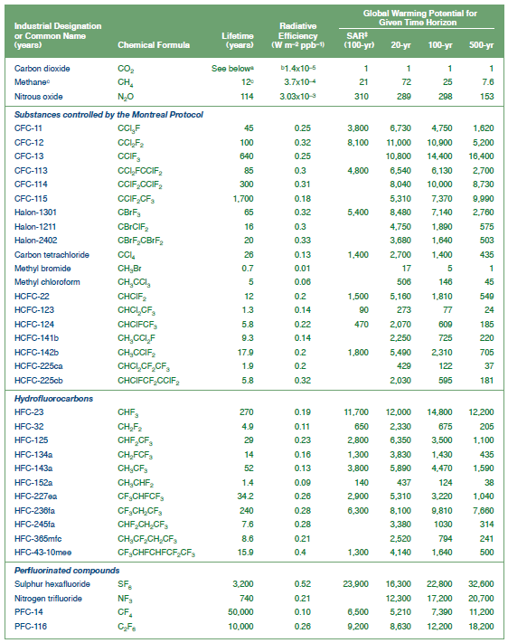

## Contacts

* Dr. Robert Seiler, CEIBS MBA2010, [srobert.m10@ceibs.edu](mailto:srobert.m10@ceibs.edu)
* Eric Seidner, CEIBS MBA2010, [seric.m10@ceibs.edu](mailto:seric.m10@ceibs.edu)
* Alex Song, CEIBS MBA2010, [sbenshuai.m10@ceibs.edu](mailto:sbenshuai.m10@ceibs.edu)
* Juan Francisco Garcia, CEIBS MBA2011 (New Decarbonator Team), [fjuan.m11@ceibs.edu](mailto:fjuan.m11@ceibs.edu)
* Anchit Goel, CEIBS MBA2011 (New Decarbonator Team), [ganchit.m11@ceibs.edu](mailto:ganchit.m11@ceibs.edu)

1. United Nations; Myers, Christian Aid, 2007, ‘Human Tide: The Real Migration Crisis’
2. Annex B of the *Kyoto Protocol* lists the industrial countries that have a binding emission reduction target for the five year period 2008-2012
3. Information from the World Bank Report *State and Trends of the Carbon Market 2010*
4. Kyoto Protocol, IPCC AR4
5. IPCC AR4, 2007, www.ipcc.ch
6. http://www.ghgprotocol.org/standards/corporate-standard